The Danish Financial Complaint Board
– Basic business account

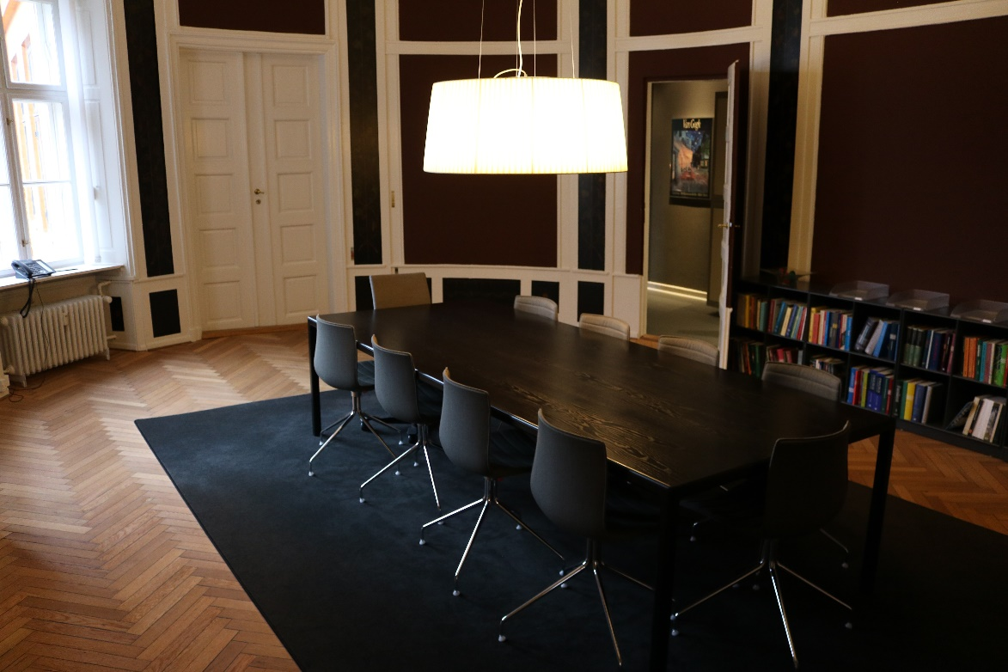

The secretariat has received your complaint

What happens next?

Information about what happens to your complaint
from receipt by the secretariat to final decision

General information to the representative of the complainant
In the following, you can read about what happens once the secretariat of the Complaint Board has received your complaint.

You may withdraw your complaint at any time. We then close the case and return the complaint fee to you.

We have organized the complaint procedure in such a way that you do not need to retain a lawyer or a legal adviser.

However, at any time you may seek independent advice, representation or assistance by a third party.

Neither party pays costs to the other.

The Complaint Board’s handling of your complaint does not exclude the possibility of a later review of your case by a court of law.

Communication between you and the Complaint Board takes place via the complaint portal (or by ordinary mail). You can find the user manual to the complaint portal on the Complaint Board’s website, www.fanke.dk.

The financial institution is informed about your complaint
Once the secretariat has registered your complaint, the financial institution is granted access to the complaint via the complaint portal.

We ask the financial institution to respond to the complaint. The financial institution has five weeks to submit its first response.

Having received the first response, you then have three weeks to make additional comments via the complaint portal.

We may extend the deadline if you or the financial institution so require.

Further information about the complaint
The Complaint Board decides on the complaint on the basis of the written documentation we receive from you and the financial institution. Therefore, it is important that both parties are given the opportunity to review and comment on each other’s viewpoints.

Comments received from you are forwarded to the financial institution which in turn gets a chance to present its points of view via the complaint portal. You then have another opportunity to submit comments. This procedure continues until both parties have no more comments or fail to respond within the set deadline.

The secretariat now considers that all information in the case has been made available. You will be informed that the secretariat starts preparing the case so that it may be presented to the Complaint Board.

This entire procedure takes place via the Complaint Board’s complaint ESS portal.

Some cases are closed at this stage of the process because the exchange of information and views result in an agreement between the parties. In that case, your complaint fee will be refunded.

The secretariat writes a presentation of the case

If the complaint is not resolved at this stage, the secretariat writes a presentation of the case based on the available information. If the secretariat finds that the information made available by both parties is insufficient, it will request further details. This means that a new deadline starts for when the Complaint Board is to make a decision. The new deadline runs from the date the secretariat receives the requested information.

In the case presentation, the secretariat outlines your complaint and the evidence supporting it, followed by the financial institution’s reason for not complying with your claim.

The case will then be submitted to the Complaint Board for its decision.

Who considers your complaint
A complaint is considered by either the chairman or a vice-chairman of the Complaint Board and two members appointed by one or more representatives from the companies and associations as well as two members appointed by the financial institution’s business organisation, Finans Danmark. The chairman and vice-chairmen of the Complaint Board are judges.

A list of the members of the Complaint Board is available on the Complaint Board’s website, www.fanke.dk/Basal erhvervskonto.

The founding organisation may authorise the chairman to decide certain complaints on behalf of the Complaint Board for which established practice exists.

Well before a meeting, the members of the Complaint Board taking part in the meeting are given access to the case and the secretariat’s presentation of the case with appendices.

The case is discussed at the meeting and if the members do not agree, the decision is put to a vote. The decision is made after a legal and professional assessment of the circumstances of the case.

The decision

The result of a decision may be that the complainant or the financial institution succeed with their complaint (in part or in full). In very few cases, the Complaint Board cannot consider the complaint.

The written decision contains a presentation of the case and the Complaint Board’s reasoned decision.

The chairman or vice-chairman of the Complaint Board signs the Complaint Board’s reasoned decision.

You will be notified by the secretariat when a decision has been made in your case. Normally, the parties can access the decision via the complaint portal a couple of weeks after the Complaint Board’s meeting.

The decision will state if the complaint fee will be refunded.

Does the financial institution have to comply with the decision?
If the complainant succeeds with his/her complaint (in full or in part), the financial institution is given 30 days after being notified about the decision to consider whether to comply with the decision.

The financial institution is bound by the Complaint Board’s decision unless it notifies the secretariat before expiry of the deadline that it does not intend to comply with the decision.

If the financial institution does not wish to be bound by the Complaint Board’s decision, you may take the complaint to court.

If the decision is not in the complainant’s favour, the complainant may also take the complaint to court.

If the complainant wants to take the complaint to court, the complainant must do so as soon as possible and no later than one year after the Complaint Board’s decision, as the claim may otherwise become time-barred.

In all events, the secretariat will inform you about your options in detail when we send the decision to you.

Complaint processing time

The Complaint Board wants to provide a simple, affordable complaint handling procedure.

A relatively short complaint processing time is the goal, but the Complaint Board must naturally comply with normal procedural guarantees, which may affect the complaint processing time.

The Complaint Board and the secretariat try to keep the complaint processing time as short as possible.

Website

Previous decisions made by the Complaint Board, its Statutes and the complaint handling procedure can be found at the Complaint Board’s website, www.fanke.dk/Basal erhvervskonto.

Contact the secretariat

You can contact the secretariat on tel. no. +45 35 43 63 33, Monday-Friday, 10.00 am to 12:00 pm. You can also contact the secretariat by e-mail, sek@fanke.dk.

It will simplify the process if you give your case number when contacting the secretariat. The Complaint Board’s case number appears in letters from the secretariat.

The secretariat of the Danish Financial Complaint Board
Telephone: +45 3543 6333 (10:00 am-to 12:00 pm)
e-mail: sek@fanke.dk
Website: www.fanke.dk

